Council of Governors (Public Meeting)

Tuesday 8 May 2018

OUR STRATEGIC OBJECTIVES
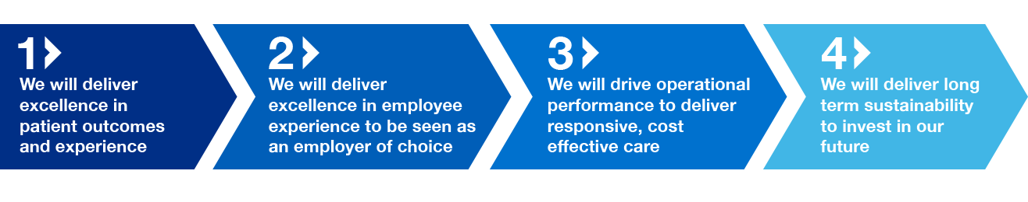
Council of Governors (Public)

Please note that in accordance with the Council of Governors Standing Orders, no filming or recording of the meeting is permitted. There will be an opportunity for questions and comments from members of the public at the end of the meeting.

Agenda

 | SUBJECT | PAPER | LEAD | TIME
1 | Welcome | verbal | Chairman | 2.00
2 | Apologies for absence | verbal | Chairman
3 | Declarations of Interests  Any new conflict of interest and  Any actual or potential conflict of interest in relation to any matter to be discussed | verbal | Chairman
4 | Minutes of the meeting held on 13 March 2018  To receive and approve the minutes from the meeting held on 13 March 2018 | A | Chairman
5 | Matters arising from the minutes and any outstanding actions  To discuss any matters arising from the Minutes not covered elsewhere on the agenda | verbal | Chairman
6 | Chairman’s Report  To receive a report from the Chairman  6.1 – Constitution  To approve updates in line with 2012 NHS Act | B  C | Chairman
7 | Chief Executive’s Report  To receive a report from the Chief Executive | D  TABLED | CEO
8 | Presentation from Mike Ducker  Mr Ducker to present to the Council of Governors as newly appointed Non-Executive Director | verbal | Mike Ducker
9 | Presentation from Adrian Clements  Urgent & Emergency Care – Centre Update | verbal | Adrian Clements
 | QUALITY, SAFETY AND PERFORMANCE
10 | Staff Survey | presentation | Paula Iddon
11 | Annual Operating Plan Update 2018/19 | presentation | Steven Mason
 | GOVERNORS TOPIC OF INTEREST
12 | Bed re-configuration and Lessons Learnt | presentation | Gill Hunt
13 | Quality Report Indicators | verbal | Gill Hunt
14 | Any Other Business
15 | Evaluation of Meeting
16 | Time and Date of next meeting  The next meeting of the Council of Governors to be held in public is scheduled to take place on Tuesday 10 July 2018 at 3.00pm in the Board Room, James Cook University Hospital, TS4 3BW.

