Council of Governors (Public Meeting)

Tuesday 13 March 2018

OUR STRATEGIC OBJECTIVES
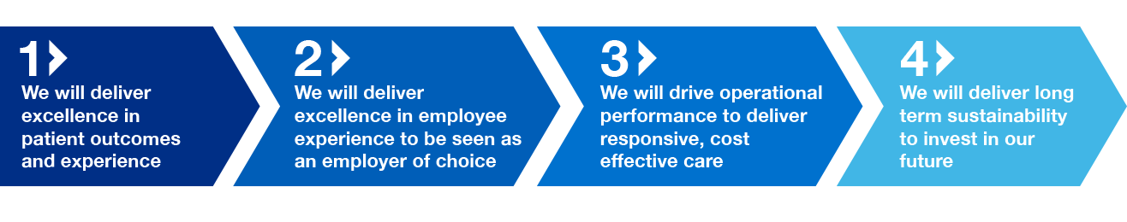
Council of Governors (Public)

Please note that in accordance with the Council of Governors Standing Orders, no filming or recording of the meeting is permitted. There will be an opportunity for questions and comments from members of the public at the end of the meeting.

Agenda

 | SUBJECT | PAPER | LEAD | TIME
1 | Welcome | verbal | Chairman | 3.00
2 | Apologies for absence | verbal | Chairman
3 | Declarations of Interest  To declare any interests members may have in connection with the agenda and any further interests acquired since the previous meeting including gifts and hospitality (accepted or refused) | A | Chairman
4 | Minutes of the meeting held on 12 December 2017  To receive and approve the minutes from the meeting held on 12 December 2017 | B | Chairman
5 | Matters arising from the minutes and any outstanding actions  To discuss any matters arising from the Minutes not covered elsewhere on the agenda | verbal | Chairman | 3.15
6 | Chairman’s Report  To receive a report from the Chairman | C | Chairman | 3.25
7 | Chief Executive’s Report  To receive a report from the Chief Executive on current issues | D | Deputy CEO | 3.35
8 | Presentation from Chairman  Mr Downey to present to the Council of Governors as newly appointed Chairman | verbal | Alan Downey | 3.45
 | QUALITY, SAFETY AND PERFORMANCE
8 | Integrated Quality, Finance and Performance Report 2017/18  - Integrated Performance Report – for information | E |  | 3.55
 | ITEMS FOR INFORMATION
9 | Any other business
10 | Questions from the public
11 | Time and Date of next meeting  The next meeting of the Council of Governors in public will be held on Tuesday 8 May 2018 at 3.00pm in the Board Room, Friarage Hospital, Northallerton, DL6 1JG.

