**Armed Forces Community**

**Awareness Pack**

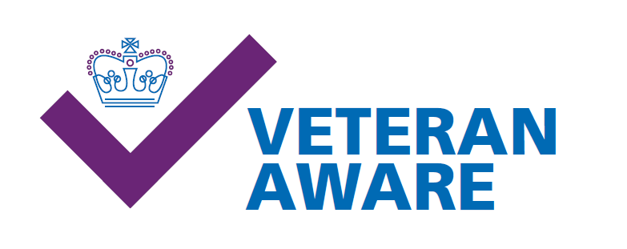

**Who are the Armed Forces (AF)Community?**

* In the UK, a veteran is defined as anyone who has served for at least one day in HM Armed Forces (Regular or Reserve) – this includes national service and Merchant Seafarers​
* It also encompasses wider AF Community, Regular, Reservists, Veterans, Spouses and children

**What should I ask the patient?**

* Please try not to ask “ Are you a veteran?”  but rather “Have you or anyone in your immediate family ever served in the Armed Forces?”

**Why?**

The Trust is a veterans accredited organisation, meaning that we have signed up to the Armed Forces Covenant.

Healthcare providers are expected to:​

​

* Ensure this community does not experience disadvantage as a result of their service compared to other citizens.​

​

* Special consideration is appropriate in some cases for those who have given the most such as the injured or bereaved. ​

​

* Family members should retain their places on NHS waiting lists if moved around the UK due to the service person being posted.​

​

* Veterans should receive priority treatment for a service related health condition/injury, subject to clinical need.​

​

* Cared for in a way which reflects the nation’s moral obligation and by healthcare professionals with an understanding of the Armed Forces culture.

**What does this practically mean for me?**

* Please add their AF status to e-camis (via a CPI flag). Graphical user interface, text, application

  Description automatically generated